How to achieve a century long live life?

Maxim Bilenkin
Department of Science and Technology, Bellevue University – Bellevue
DSC 500: Introduction to Data Science
Professor Fadi Alsaleem
September 12, 2024

How to achieve a century long live life?
Many people today wondering how to live a long life. A lot of articles on the news available for this topic. Research and studies have been conducted on the diet and life styles of centenarians. But perhaps they are all contradictory. Some studies found eating good food is the answer. Another study found eating fewer or perhaps one meal a day will prolong our lives. Other surveys claiming breathing fresh air every day and regularly exercise are the key ingredient for long life. All these findings make sense but at the same time contradictory. Many centenarians live in cities without fresh clean air, eating not the healthiest foods, do not exercise and yet able to reach a century. So, what is the secret sauce to live a long life and reach a century? What do all centenarians have in common? Are there any similar patterns they have in common?

One of the earliest studies on prolonging animals’ lives and reverse aging was done back in the ninety thirties by Clive Maine McCay, who was a professor of animal husbandry and scientist at Cornell University. In his study called “Caloric Restriction” he used A/B testing for two groups of rats (see for reference on last page). In one group he placed rats and fed them very little keeping the group nearly starved. The other group was fed well. What he discovered was the group that fed very little and kept semi starved lived thirty three percent longer than the other that fed well. Perhaps, may be the same principal can be applied to human beings? This study triggered many different research on how to reverse human aging. Scientist conduct all type of different experiments trying to discover the medicine or ways that will prolong our lives.

How to achieve a century long live life?
Interviewing centenarians around the world form various insights and suggestions on how to live long life. It seems each group influenced in different part of the world by their culture, country, religion and believe. The advice they give varies. For example, in Japan long live people believe green tea, fresh air and sea food especially fish that is rich in omega-3 oil are the key to live a long life. But that is contradictory to the centenarians that live in the United States of American in big cities without breathing fresh air, eating burgers and pancakes.

Using Google Trends and running the following phrase “how to live to one hundred years” over the last twenty years returns not impressive interest in this topic around the world. The curve is flat from 2004 until October 2019. Very interesting phenomenon. Is it fare to say that people were not interested until October 2019 about how to live longer and then suddenly became very interested because of some event probably happened. And if that is the case then why in October 2019. Was there anything happening back then that finally triggered people’ interest on the topic? May be the Covid-19 pushed people to think more about their longevity and health. The global pandemic started in the second half of November 2019. At least the news start circling in the media. Perhaps that might be a good explanation as people strart getting more news about the topic they became more concern about their health and start searching for answers on Google. The World Health Organization officialy declared Covid-19 as global pandemic on January 30, 2020 according to the U.S. Department of Defence. See last page for refference.

How to achieve a century long live life?
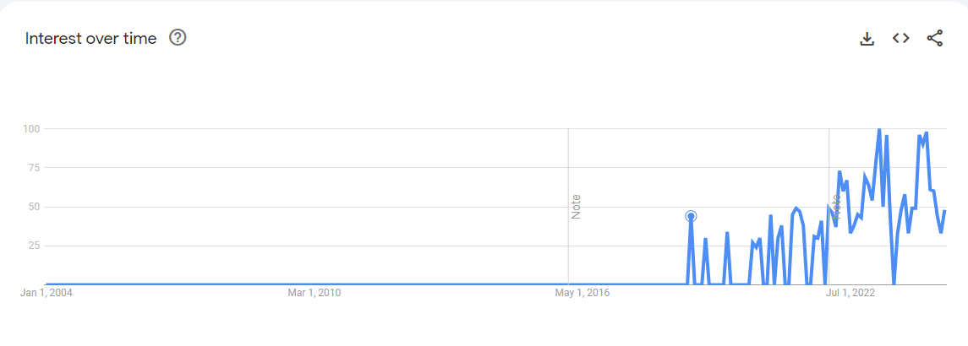
Apparently, taking as a single region the largest number of people that express interest about life longevity located in the North America. Accounting Philippines, Vietnam, and Indonesia as one group since all three located in Asia then we can see that the total number is overwhelmingly bigger than in the U.S. We know that the Covid-19 started out of Asia. It might be a good explanation the total number of individuals as a group were much higher in the region because their society were more informed ahead of North American population. Thus, more searches in total. 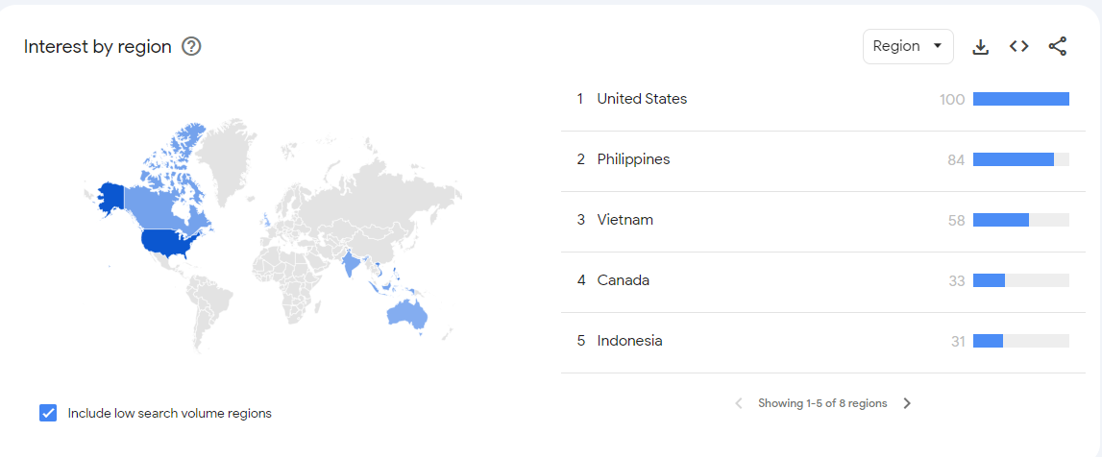

How to achieve a century long live life?
Searching “100 years old person” returns more searches over time. At least beginning from March 2009 people in thirty regions expressed increasing over time interest in long living person’s life. This time Guyana was the leader. Doing my research on any event that happened back in March 2009 in Guyana I came across a big event that took place at that time. On March 29, 2009 the Los Angeles Times newspaper reported that Janet Jagan a U.S born former Chicago nursing student and the first female white person to become a President of Guyana has died at the age of 88 (please see last page for reference). Although, she did not live to 100, nevertheless this could be a good explanation that people especially women were interested how she was able to live relatively long live and start searching for answers. 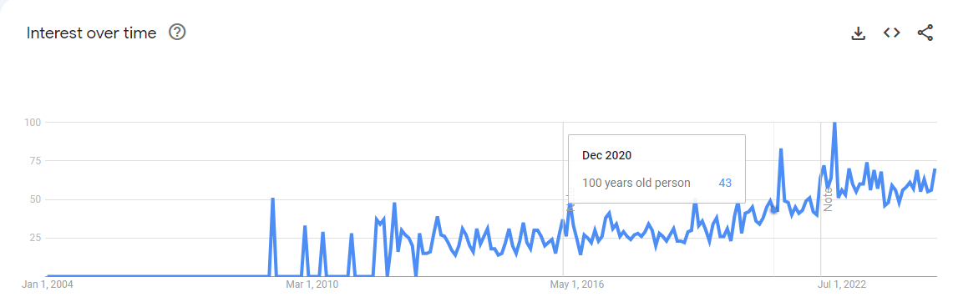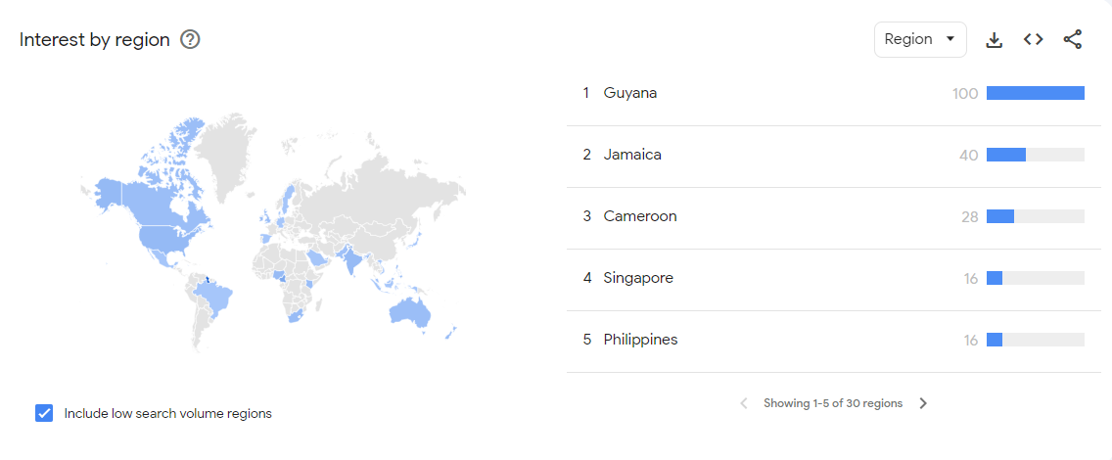

How to achieve a century long live life?
Running search query “food for long live life” generates the following graph. Starting from March 2010 very low interest was expressed. But starting from the mid 2017 more interest in the food that can help to extend longevity and apparently more individuals from Nepal than any other were curious. Perhaps may be due to the study that was conducted on type 2 diebetes in Nepal from June 2017 and beyond on the food diet that people each made people more councious about their helth and they start searching for answers what food to eat to prolong their life. Plase see reference for source. 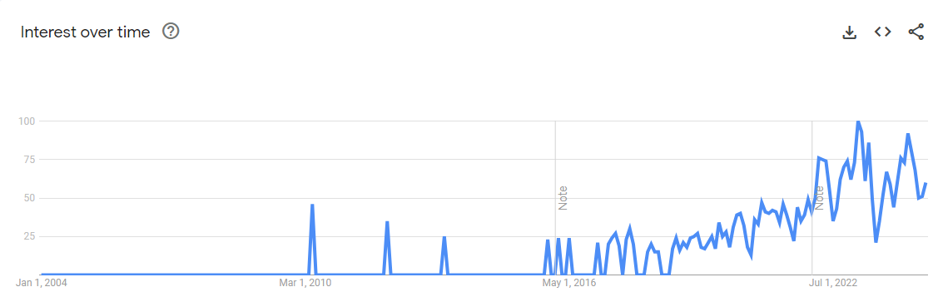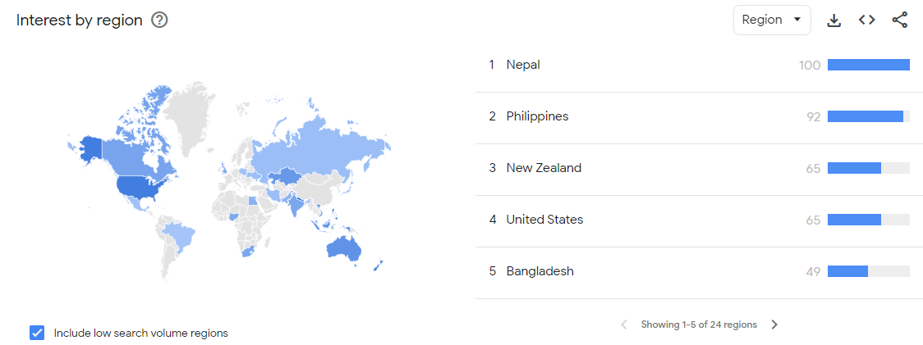

How to achieve a century long live life?
Searching for “Do vegetarians live 100 years” returned only interest from Azerbaijan back in February 2009 which does not give any insight. There were no major events happened in the country during the time. Only one study was conducted by Internal Displacement Monitoring Center or simply IDPC on July 14, 2008 which was far before February 2009 (see last page for reference). The article called “Azerbaijan: IDPs still trapped in poverty and dependence” on page 7 under a header “Health of IDPs and accessibility of health care” describes about health and availability for displaced people. Probably the same situation applies to the entire country. It is not a secret after the collapse of the Soviet Union, Azerbaijan at least at the time when the survey conducted did not have a good health system available to its population. So, perhaps people in the country stopped relying on their government and began searching for answers on how to prolong their life. 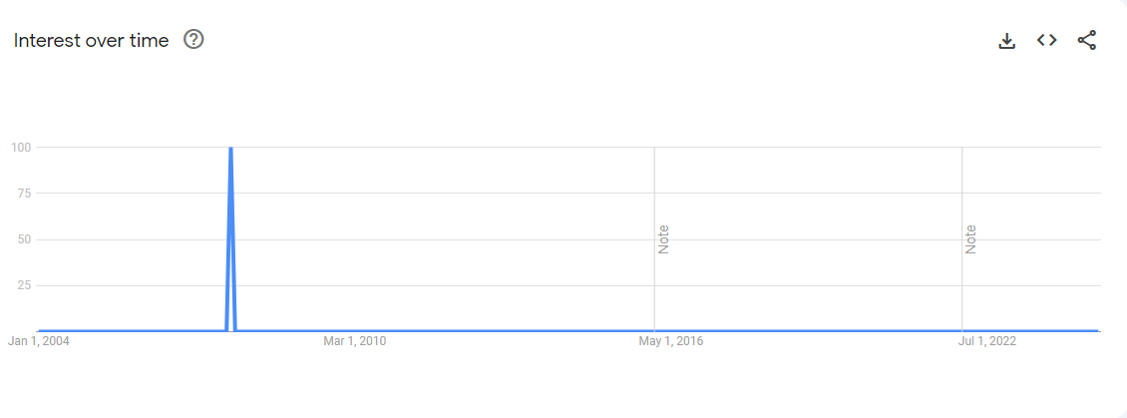

How to achieve a century long live life?

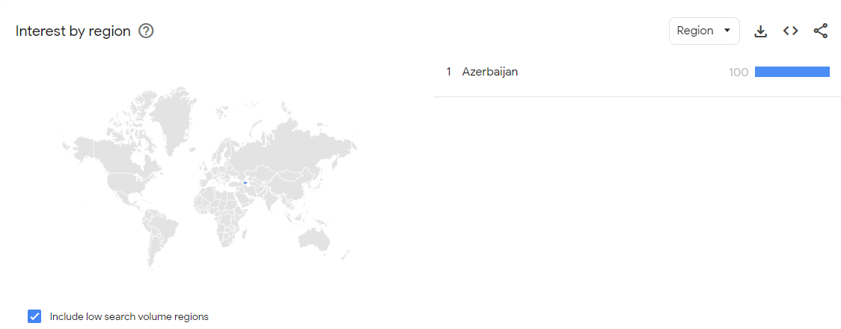
Finally, searching for “should one exercise to live longer” returns interest of over 100 searches and the most interested individuals located in Togo, the country I had never heard of in West Africa. It was reported by the news that Emmanuel Adebayor a Real Madrid soccer striker returns to Togo (Please see reference for source). This could trigger peoples’ interest to find out if they should exercise by playing soccer or other sport to live longer.

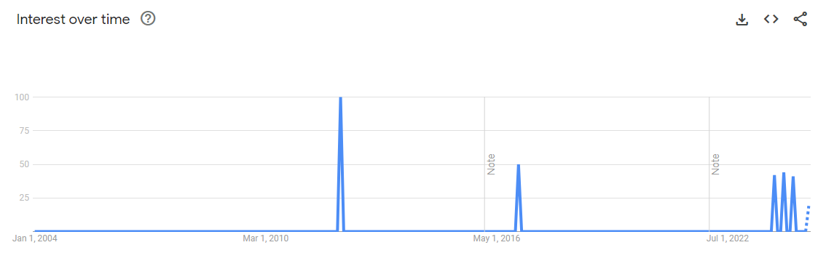

How to achieve a century long live life?

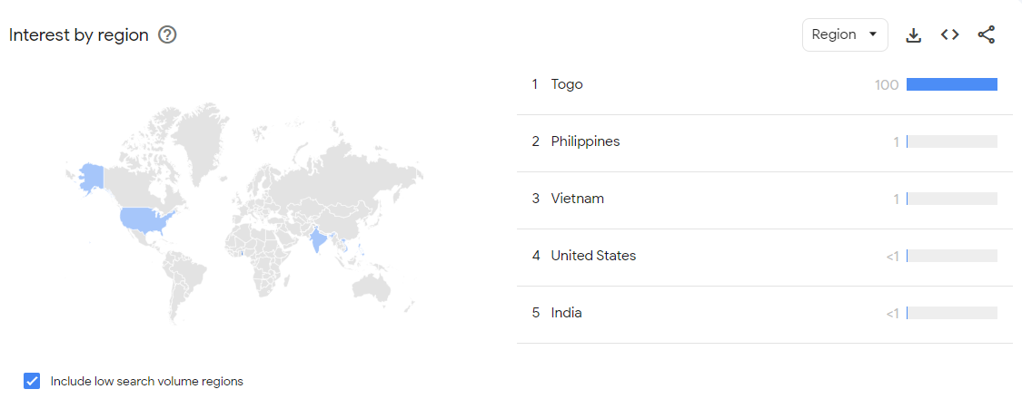

Conclusion
Clearly, we can see from the Google Trends over the twenty years’ time span the overall interest is not that big on how to achieve a century long live life. In addition, it does not give much insight on how to achieve it. It shows peoples’ interest on finding the answers but doesn’t tell us what directions we should take. I would like to find out what in common centenarians have. What habits, foods, and life style do they share. All these findings hopefully will give some clue and pattern that will finally uncover the secret of achieving century old live life.

References
The Journal of Nutrition. Honoring Clive McCay and 75 Years of Calorie Restriction Research
https://www.ncbi.nlm.nih.gov/pmc/articles/PMC2884327/
The Economist. Longevity: can ageing be reversed?
https://www.youtube.com/watch?v=FYr04ymjD1w&t=403s
U.S. Department of Defence (Coronavirus Timeline)
https://www.defense.gov/Spotlights/Coronavirus-DOD-Response/Timeline/
Los Angeles Times
https://www.latimes.com/local/obituaries/la-me-janet-jagan29-2009mar29-story.html
Perceived impact of Nepalese food and food culture in diabetes
https://www.sciencedirect.com/science/article/abs/pii/S0195666317303677
Adebayor returns for Togo
https://english.ahram.org.eg/NewsContent/6/54/8378/Sports/Africa/Aboutus.aspx
State of emergency medicine in Azerbaijan
https://www.ncbi.nlm.nih.gov/pmc/articles/PMC2536184/

